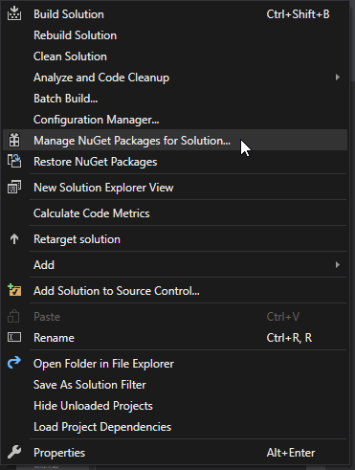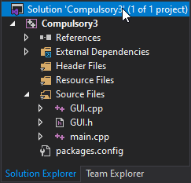First you need to right click on the projects solution. Then click Manage NuGet Packages for Solution.

Then Browse and search for Allegro.

Install both Allegro and AllegroDeps.

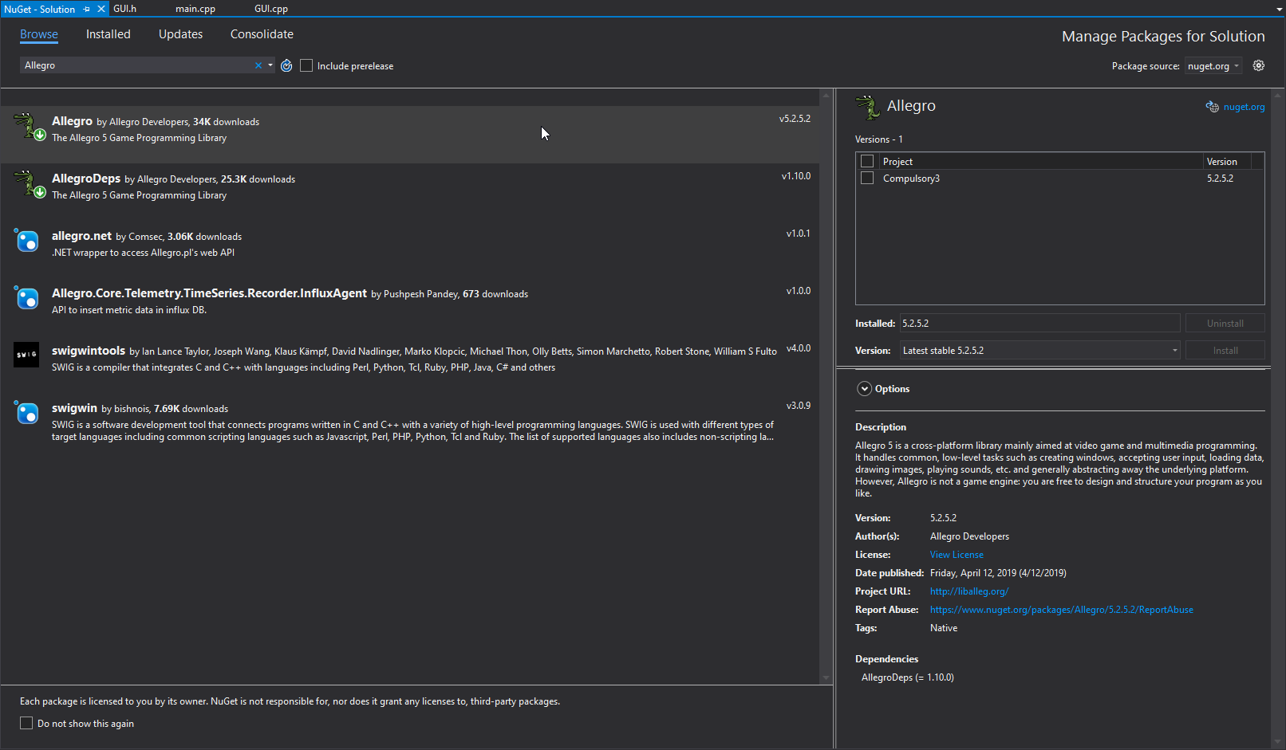

Then you need to right click the project and select properties.

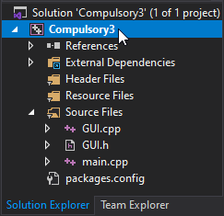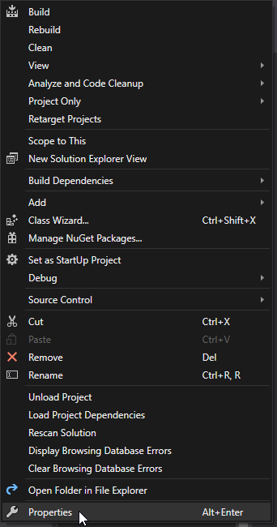

Make sure that the Truetype Font, Primitive, and Font addons are included.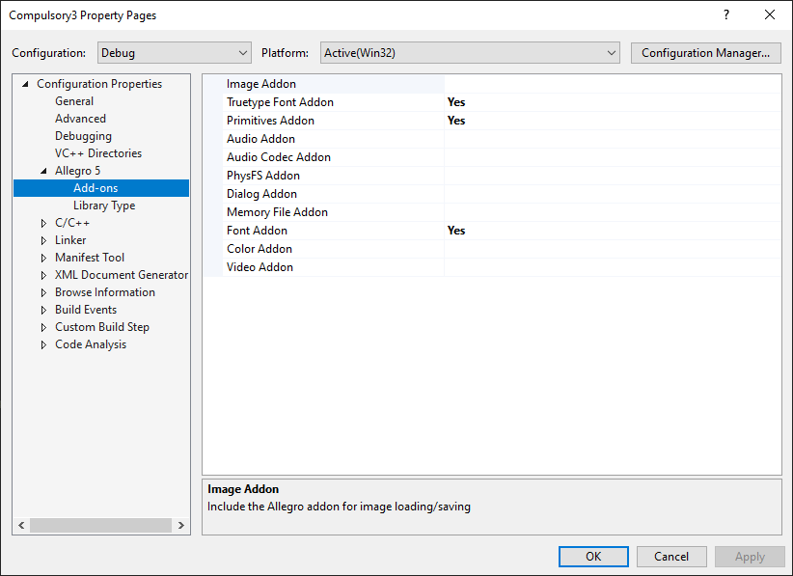

And the library type is set to: Dynamic Debug – Dynamic Runtime. 